Exploring the HC2000 ROM circuitry, and adding 64K of flashram.
This is the journal of my experiments, and definitely not a DIY guide!
Parts of this story were already made available. Roelof Koning, 2006.
=================================================================================


The HC2000 has been marketed in (at least) two versions:
One with a 27C256 EPROM on the calculator part of the Printed Circuit Board (PCB, left hand side) together with a 27C128 EPROM on the IF1 interface part. (right hand side). This version also has two RAM chips type 2114 on the interface part of the PCB.
Another version holds only a 27C512 EPROM on the calculator part of the PCB, and one 6116 RAM chip on the disk interface part of the PCB. It appears that the PCB is prepared for both versions, although the '64K' version probably needs some modifications as on my board there are a few extra wires. So the second version has 16K of ROM and 1K of RAM more than the first version! a retro freak

My HC2000 has the EPROM type 27C512 on board which holds 64K of data:
0 - 16383 = the IF1 system
16384 - 32767 = almost identical copy of 0-16 (not used!)
32768 - 49151 = the Spectrum BASIC with some extra code at 14446
49152 - 65535 = the 8K CPM BIOS and bootstrap loader

16K of this ROM is visible for the hardware when BASIC is running, another block of 16K is present when the IF1 is doing its jobs. A third 16K block of this EPROM holds the code used by CPM. In fact this third block holds two times the 8K of CPM code. The fourth 16K block holds an older version of the IF1 code, which in fact is not used at all!
The switching between the lower and upper 32K is done by a RST8 instruction,
which acts on the A15 adress line. The switching between the lower and upper
half of such 32K block is done by bit 0 of port 126, which acts on A14.
The 2K RAM chip type 6116 is addressed as a block of 1K, and found on addr. 10240-11263, 11264-12287, 14336-15359 and 15360-16383, as soon as the lower 32K of the EPROM is paged in. Indeed, the same 1K of RAM is found 4 times in both the IF1 bank or the Copy-IF1 bank.

The conclusion must be that a lot of ROM space is lost due to the design. Not only a whole 16K bank is not used, but also 8K inside the CPM bank is redundant and in the IF1 bank the space from 11263 –16383 could be made available, of which 11263-12287 would be RAM.

I wanted to make this all available to me on my HC2000, as it is my hobby to program on ‘system-level’.

Phase 1
The reason for the 1K 'barrier' of the 6116 RAM is very simple, the signal line used to address the second half (1-2K), connection A10, is simply connected to 'ground'! Which means that when this 1-2K block is selected, the (low) 0-1K block appears again. This problem is solved by cutting a small copper trace between pins 19 and 20 of the 6116 chip, and wiring the ‘freed’ pin 19 to the Z80’s A10 address line.

Phase 2
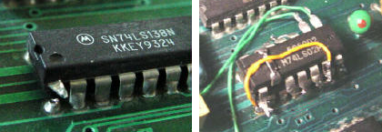

Here is shown
how I did the
phase 2 job.

The ‘mirroring’ of the 6116 chip in the IF1 space comes from the fact that
the address line A12 is not taken into account by the 74LS138 type decoder,
while A11 and A13 are. The problem is solved by adding this A12 signal by
means of a few extra logic gates. The picture above shows how a 74LS02 is soldered on top of the 74LS138. Note that also A14 is brought in to make it possible to discriminate between the 0-16K bank and the copy at 16-32K.
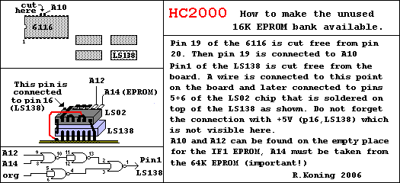
This prevents the RAM from paging in while the fourth EPROM bank is active.

Phase 3
An EPROM chip is electrically selected with two signals, one to the /CE pin (Chip Enable), and one to the /OE pin (Output Enable. For unknown reasons the HC2000 has the Z80’s /MREQ signal connected to /OE, and has the Z80’s /RD signal left out of the decoding. This means that the EPROM presents its data not only during a ‘read’, but also when something is written to it. This rather unusual design prevents the owner to exchange the EPROM with a
FlashRAM, exactly the thing I had in mind. Fortunately my EPROM was already mounted in a socket, and I did not have to arrange that first.
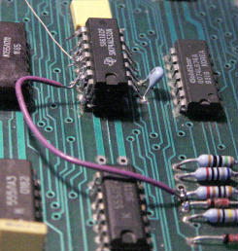

Shown here is half of the phase 3 job.
A 74LS32 chip is soldered ‘piggy back’
on top of another. Only one of the four
gates is used to add /MREQ to the ROM-
select signal.

For a number of reasons I wanted to keep the EPROM also. The main reason is that I need a ROM with a valid content, to make the paging by RST8 work!
So I soldered a 28 pin socket on top of a 32 pin 28F010 FlashRAM chip, leaving pin 22 (/CE) out by bending it sideways.
I also bent away to a horizontal position, the pins 1 and 2, 31 and 32, and the pins 22 (/OE) and 24 (/CE) of the 28F010 .
This chip was then mounted in the EPROM socket leaving pins 1, 2, 31 and 32 outside. On top the EPROM is inserted. See the picture for details.

In fact the drawing depicts the situation before I had to replaced the Z80, and mounted it on a socket. Since then the whole ROM contraption is put on another socket just to gain height.
Note that the EPROM goes into the socket on top and has none of its legs bent! Unlike the FlashRAM.....
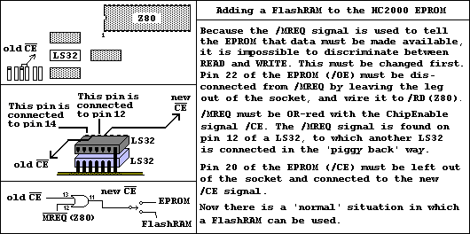
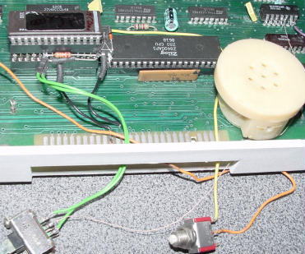
In the world of FlashRAM there exist two different groups, the models that need 12 Volt to be programmed, the 28-series, and the models that work with 5 Volt only, the 29 series. I used a 28-type, because these can be write-protected by switching the 12V off. The smallest size is 128KB, of which I only use 64 KB. Whether the lower or the upper bank is used, depends on the voltage on pin 2. As the so called ‘boot block’ appeared to be of no use for me, I choose to have the lower bank and wired pin 2 to GROUND.
To have the Vpp pin 1 connected to ‘something’ on the moments when there is no 12V, I connected it to +5V by means of a diode. As ‘GROUND’ is available on pin 2, I instead could have connected Vpp (pin 1) with a resistor to this GROUND.
The picture shows the inserted ‘EPROM-tower’. Visible are two black wires connected to /RD and /WR, the two resistors that ‘pull up’ both /CE connections, and the two green wires going to the ROM/Flash switch. The very thin wire goes to the new /CE.
The 12V (yellow wire) is connected through a push button that must be pushed during programming. This might be replaced by an other switch.

I always work with parts that I find in the junkbox, and had no specific reason to choose the 28F001. There are several other types available in the 28-series and 29-series that can do the job.
For programming the FlashRAM, I start the HC2000 with the EPROM selected. All works under standard BASIC now, and the progam and data files can be loaded from disk. My program beeps (for about a second) two times, to signal the moments on which the FlashRAM must be switched in and out. So the whole
is done from standard BASIC.

Phase 4
Programming and erasing a FlashRAM 28F001.
Other types of flashram may need other routines!!

;? * TORNADO * Roelof Koning 2006
;------------------------------------------------
; For HC2000
; Reading all banks from both EPROM and FlashRAM
; Writing all banks into FlashRAM
; 28F001
;0-16 = IF11, 16-32 = IF12, 32-48 = BAS, 48-64 = CPM
;------------------------------------------------

ORG 48000
DUMP 48000

JP readbas ;0 USR 48000
JP readcpm ;1 USR 48003
JP readif11 ;2 USR .....
JP readif12 ;3 ... ..etc.
JP writebas ;4
JP writecpm ;5
JP writeif11 ;6
JP writeif12 ;7
JP identify ;8
JP erase ;9

; ---- POKE THESE! ----
loadreg LD DE,0 ;start + 31/32
LD HL,49152 ;start + 34/35
LD BC,16384 ;start + 37/38
RET

;?--------------------------------------------------------
erase DI
CALL beep ;time to switch ROM!!
LD A,#50 ;reset status
LD (000),A
LD A,#20 ;erase1
LD (000),A
LD A,#D0 ;erase2
LD (000),A
ready1 LD A,(000) ;read status !!
BIT 7,A
JR Z,ready1 ;1=ready
AND %00111000 ;keep bits 3,4,5
LD B,0
LD C,A ;now C holds status
eexit LD A,#50 ;reset status
LD (000),A
LD A,#FF ;back to normal read
LD (000),A
CALL ready ;delay + beep
EI
RET

;?--------------------------------------------
identify DI
CALL beep
LD A,#50 ;reset status
LD (000),A
LD A,#90 ;identify
LD (000),A
LD BC,(0000) ;read identifs
JR eexit ;back to nornal

;?---------------------------------------------
readbas CALL readbas1 ;without EI!
EI
RET

readbas1 DI
CALL beep ;time to switch ROMs!
CALL loadreg ;poked from basic
LDIR
ready PUSH BC ;save result
LD BC,65535 ;max delay
delay DJNZ delay
DEC C
JR NZ,delay
CALL beep ;time to switch again!!
POP BC
RET ;back to basic

;?----------------------------------------------
readcpm CALL readcpm1 ;without EI!
EI
RET
readcpm1 DI
CALL beep ;time to switch ROMs!
CALL loadreg ;poked from basic
LD A,1 ;CPM or IF1-2 bank
OUT (126),A
LDIR ;fetch code
XOR A ;BASIC or IF1_1 bank
OUT (126),A
JR ready

;?---------------------------------------------
readif11 LD HL,readbas1 ;same routine
JR rprep
readif12 LD HL,readcpm1
rprep LD (23789),HL
RST 8
DEFB #32 ;make sure IF1 is in
EI ; and run (23789)
RET ;page out here!

;?=============================================
writebas CALL writebas1
EI
RET

writebas1 DI
CALL beep ;time to switch ROMs!
CALL loadreg
EX DE,HL
CALL dowrit ;BASIC
JP ready

;?---------------------------------------------
writecpm CALL writecpm1
EI
RET

writecpm1 DI
CALL beep ;time to switch ROMs!
CALL loadreg
EX DE,HL
LD A,1
OUT (126),A
CALL dowrit ;the actual writing
XOR A
OUT (126),A
JR ready

;?---------------------------------------------
writeif11 LD HL,writebas1 ;same routine!
JR wprep
writeif12 LD HL,writecpm1 ;also same routine!
wprep LD (23789),HL
RST 8
DEFB #32 ;make sure IF1 is in
EI ;IF1 ROM paged out now!
RET ;exit MC here

;?-----------------------------------------------
dowrit LD A,#50 ;reset status
LD (DE),A
dowrit1 LD A,#40 ;write setup
LD (DE),A
LD A,(HL)
LD (DE),A
getstat LD A,(DE) ;read status
BIT 7,A
JR NZ,getstat ;until ready
AND %00011000 ;keep bits 3 and 4
JR NZ,wexit ;error
INC HL
INC DE
DEC BC
LD A,B ;test for last
OR C
JR NZ,dowrit
wexit LD B,0
LD C,A ;0 or status
LD A,#50 ;reset status
LD (000),A
LD A,#FF ;back to normal read
LD (000),A
RET

;?--------------------------------------------
beep LD E,0
LD A,16
LD HL,1000
beep1 DEC E
JR NZ,beep1
XOR 16
OUT (254),A
beep2 DEC E
JR NZ,beep2
DEC HL
LD D,A
LD A,H
OR L
LD A,D
JR NZ,beep1
RET

;the end --------

